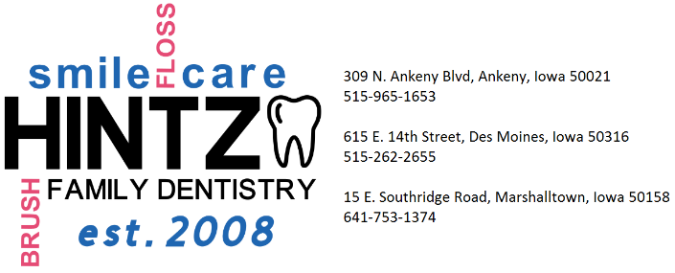

Acknowledgement of Hintz Family Dentistry Policies
(Please see the back to review these policies.)
I, |  |  |  |  | authorize Hintz Family
 | (Patient or Parent/Guardian’s name, if minor)
Dentistry to submit claims on my behalf to insurance and/or other third parties. I consent to Hintz Family Dentistry to disclose health information to the extent necessary to obtain payment and assigns benefits paid by insurance or third parties directly to Hintz Family Dentistry. In consideration of the dental services provided, the undersigned assigns to Ankeny Dental Associates any benefits to which the undersigned may be entitled to receive, including without limitation any such benefits due or claims the undersigned has under or pursuant to a benefit plan governed under ERISA, 29 USC sec. 101 et seq.

I have reviewed Hintz Family Dentistry’s policies as listed on the back of this form and I understand and accept responsibility of cooperating with these policies. I understand that I will be responsible for financial balances resulting from treatment received that is not paid by my insurance company or any third party agency.

My signature acknowledges that I understand and accept the above agreement.
Patient Name (Print)
Signature |  |  |  |  | Date | / /
 |  | (Patient or Parent/Guardian’s name, if minor)
Witness Signature |  |  |  |  | Date | / /

Acknowledgement to Receipt of Privacy Practices
You may refuse to sign this acknowledgement, but by doing so, we may decline treatment.
I, |  |  |  |  |  |  | have received a copy of Hintz
 | (Patient or Parent/Guardian’s name, if minor)
Family Dentistry Notice of Privacy Practices version 2.0 with an effective date of November 11, 2015.
Patient Name (Print)
Signature |  |  |  |  |  |  |  | Date | / /
 |  | (Patient or Parent/Guardian’s name, if minor)
Witness Signature |  |  |  |  |  |  |  | Date | / /

Verbal Communication Permissions
Individual(s) that may receive communication from Hintz Family Dentistry regarding you.
 | ( ) -
Name | Phone # | Relationship
 | ( ) -
Name | Phone # | Relationship
 | ( ) -
Name | Phone # | Relationship

Hintz Family Dentistry’s Policies
Consent to Treatment
By signing the acknowledgement, the signee consents to dental treatment, including radiographs (x-rays), laboratory procedures, local anesthetic, diagnostic tests, or other procedures, rendered to the patient under dentist supervision. Although the signee may elect not to undergo certain specific procedures, without adequate diagnosis or treatment plan, Hintz Family Dentistry may decline to treat the patient.
Notice of Privacy Practices
By signing the acknowledgement, the signee has received Hintz Family Dentistry’s Notice of Privacy Practices and consents to the use and disclosure of his/her health information to carry out treatment, payment activities, and healthcare operations. The signee has the right to revoke consent at any time by written notice. However, we may decline to treat the patient if this consent is revoked.
Financial Agreement
The signee agrees, whether he/she signs as agent or as patient, that in consideration of the services to be rendered to the patient, he/she hereby individually obligates himself/herself to pay the account of Hintz Family Dentistry in accordance with the regular rates as deemed by the fee schedule. Should the account be referred for collection, the signee shall pay reasonable attorney's fees and collection expenses. If a patient's account is sent to collections, Hintz Family Dentistry will provide only emergency treatment for pain and swelling until the account is current. Failure to pay for services in a timely manner may jeopardize a patient's access to routine dental care. Patients who have dental insurance will pay his/her estimated portion at the time of service. Once insurance payment is received, the patient will be billed/refunded any difference to his/her account.
Minors and Dependent Adults
All patients under the age of 18 or dependent adults must register the name, address, date of birth, phone number, and social security number of the adult responsible for payment. Either parent or legal guardian may be held responsible for payment of treatment rendered to his/her minor child or dependent adult. In the event of a divorce or separation, both parents may be held responsible for payment of treatment rendered to their minor child.
Payment
Full payment is due on the day service is provided. Cash, check, CareCredit, and/or credit card (Visa, Mastercard, American Express, and Discover) are accepted for payment. Returned checks due to insufficient funds will incur a $25 fee.
Insurance
All insurance information must be registered at or before the initial appointment and updated when information changes. Patients must provide a copy of his/her dental insurance card. Prior approval can be submitted after presentation of a treatment plan. This is not a guarantee of payment. Patients must initiate the request. Patients who have dental insurance will pay his/her estimated portion at the time of service. Once insurance payment is received, the patient will be billed/refunded any difference to his/her account. As a courtesy, Hintz Family Dentistry submits your claim to your insurance or other third party. It is your responsibility to know what your insurance will and will not cover before your appointment.
Cancellations and Broken Appointments
If you are unable to keep your scheduled appointment, we respectfully request a 24 hour cancellation notice. If notice is not given prior to 24 hours, the appointment will be considered a failed appointment. (If you are calling after hours or on a weekend, please leave a voicemail. We will consider these as a 24 hour notice.) After 3 failed appointments, the patient will be unable to schedule for an appointment beyond the current day. At the end of the calendar year, the patient will be allowed to once again schedule for future dates up until he/she fails another appointment at which time the patient will again be unable to schedule beyond the current day.

